

**Cs 319**

**Object-Oriented Software**

**Engineering Project**

**Analysis Report**

**2nd Iteration**

Section 2 / Group 2K

Ege Darçın

Alptuğ Albayrak

Özgün Özkan

Furkan Erdem

Instructor: Bora Güngören

1. Introduction 3

2. OverView 4

2.1 Gameplay 4

2.2 Players 4

2.3 Background Selections 5

2.4 Powerups 5

2.5 Goals and Scoring System 6

3.Requirements Specification 7

3.1 Functional Requirements 7

3.1.1 Play Game 7

3.1.2 Player Control 8

3.1.3 Choosing The Character 8

3.1.4 Settings 9

3.1.5 Help 9

3.1.6 Viewing The Score Table 9

3.2 Non-Functional Requirements 9

3.2.1 Usability 9

3.2.2 Supportibility 10

3.2.3 Reliability 10

3.2.4 Performance 11

3.3 PseudoFunctional Requirements(Constraints) 11

4. System Model 11

4.1 Use Case Model 11

4.1.1 Play Game 13

4.1.2 Non-Gameplay Interactions 17

4.2 Activity Diagram 19

4.3 Class Diagram 20

4.4 Sequence Diagrams 21

4.5 State Diagram 22

4.6 Mock-Ups 23

4.6.1 Main Menu: 23

4.6.2 Player Select Menu: 24

4.6.3 Settings Menu: 25

4.6.4 Credits Menu: 26

4.6.5 How to Play Menu: 26

4.6.6 In Game Screen: 27

# 1. Introduction

Headball is an arcade game similar to “Topçu Kafalar”. In this game, the aim is to score goals against your opponent player. It is a two player game where each user controls a football player and you both try to score goals. This is a two dimentional game, where two goals on each side is placed and the football players begin the game in front of their own goal. A ball appears in the middle of the field and each player will try to hit the ball to score goals.

Heads of the players are very big compared to their bodies and the head is how the players control the ball, as a round shape it gives users a great and that way the game will be more funnier and entertaining. Players will control the footballers with arrow keys, w,a and d. Left and right is for strafing and up is for jumping. When a footballer contacts with the ball, the ball will be kicked in the angle of approach to its head. Thus, people who are playing will get confused at first how to play, this will heighten the fun. After a user gets along with the controls, they will use more complicated tactics to score and also raise up the level of fun. In order to spice things up, different ball types (Beach Ball, Rugby Ball etc.), different conditions (normal, winter etc.) and goal sizes will be set each round, if random mode is selected. Players can also play a custom game where they pick the features. Different designs of head types are implemented, users will be able to choose their player's skins. There will be 2 power-ups: faster movement and fireball. The first will double the movement speed of the player and the latter will make the player hit the ball twice as harder. Those powerups will take a short duration and will be on cooldown after its usage. If a player scores a goal, the scoreboard will be updated. If a limit of goals is decided, a user reaching that goal will win the match. Otherwise, the game will not be ended until quitted. The target platform of the game is JAVA SE. Only keyboard will be used to control the game, hosting navigation buttons and powerup buttons.

# 2. OverView

## 2.1 Gameplay

In “Headball” , your primary focus is to score more goals than your opponent. With navigation keys, you control your football player around the field. Another user is trying to do the same and both of you try to score a goal against each other’s goals. The tactics may be sometimes very simple or complicated, since both work in this game. In the game, by navigating through the field, you can both attack and defend in different ways. By standing near the goal, you can block incoming attacks and turn the tide. By going forward, you are more likely to score and clash against the opposing player. If users have chosen the random mode, in each round users will begin with different setups, big/small/normal goals, soccer ball/american football/beachball, normal/icy weather. Each case will bring a new dimention to the game in their own ways and combination of them will make the game much more fun.

## 2.2 Players

There are different numbers of characters that offered to the users of both of the opposite teams. Each player in the game has different outfit. For example, while right hand side is having lilac-dark blue outfit, left hand side has orange-blue outfit. Because of this diversity, players has a chance to express their selections by choosing the funniest head for them. Moreover, these characters provide detection of their players during the game.

As a constraint of all pllayers, characters have much bigger heads than their body size. This provides gamers to contol their players in a funnier manner, also this makes the game more funnier. The players are facing each others goals every time, this disables for users to mix up their characters during gameplay.

## 2.3 Background Selections

There are two backgrounds to play on. The first is being a normal football field, a green pitch with tribunes on the background. The physics will be familliar to the users since there is no inordinate behaviours. The second background is icy stadium. Here, the ground is much more slippery compared to the football field. This makes the control of the players much more harder. To put it mathematically, the acceleration values will be halved and accelerating/deaccelerating in the field is much more harder and users will sense a loss of control, like a car on an ice road. We believe that this will also add something to the experience.

## 2.4 Powerups

There are two types of powerups: “Fast Movement” and “Fireball”. In order to use the powerup, the user will trigger a specific powerup via a key binded to it. When a powerup is enabled, it will stay on for a while, around 3 to 4 seconds. After that, the powerup will be on a cooldown, which is shown on the UI. When the cooldown is finished, which takes around 15 seconds, the powerup will be ready to use. The “Fast Movement” powerup will enable the player to accelerate/deaccelerate two times much in the game. This will enable the player to move in the field much faster, the top speed will also be doubled. However, the control of the player will be much harder and beginners will have more difficulties to hit the ball as they wish. Advanced players will use it in a more efficient way. The second powerup will be the “Fireball” On one hand, this powerup enables the player to shoot the ball two times faster its default speed, so fast that the ball catches on fire. On the other hand, it will be very hard to stop the ball. If a ball is hit when the person has the fireball, it catches on fire and if other player try to stop the ball, the ball will have a momentum and push them a little back. Both powerups can be used in the same time.

## 2.5 Goals and Scoring System

If the ball passes the line of the goal, this will be counted as a point of the oppononet of the goal’s owner. It doesn’t depend on who touches the ball at last, it will be counted as a goal. After a goal happens, a notification popus up, telling the users who has scored the goal and the update on the current score. Meanwhile, on the background, events will be slowed down, players will be still on control of the ball. That way, the scorer may celebrate and the opposer may react to it in his/hers own way. This can be trying to remove the ball from the goal, or try to hit the opposer’s player, it is up to the players. If the limit of goals is reached, the winner is announced and the final score is shown. A dialogue of “Return to the main manu” and “Again?” will be showed up, asking users to play another round or going back to the main menu.

# 3.Requirements Specification

## 3.1 Functional Requirements

### 3.1.1 Play Game

Before starting the game, player opens the Player Select Menu and chooses the character. Since different design of heads ands skins will be implemented, user is going to have a variety of choices. After selecting the character, game will start and players will begin the game in front of their own goals which are placed to each side. With the whistle and the countdown which will start at top of the screen, game will start and the ball will appear in the middle of the field. Main purpose of the players is to score goal by hitting the ball with selected character’s head or foot. Since the designed character’s heads will be very big compared to their sizes, game will be funnier and enjoyable to play. When a footballer hits the ball, the direction of the ball will be determined in the angle of approach to its head. In order to make the game more exciting, random mode will be implemented, in which it is possible to select different balls and goal sizes. In addition, there will be two power-ups which are faster movement and fireball. If the player uses faster movement, the speed of the ball will be doubled and in the case of using fireball, character will hit the ball twice harder. After the durations of powerups expire, they will be on cooldown. Player’s score will be kept and updated on the score board which will be located on the top of the screen. When the given time finishes, player with higher score wins the game.

### 3.1.2 Player Control

Players can control the characters either using left, right,up arrow keys or w,a,d. Left and right keys are for moving to left and right and up key is for jumping. Similarly a,d keys are for moving to left and right, w is for jumping. Also the user will use the power up skills with selected key.

### 3.1.3 Choosing The Character

Using the Player Select Menu, before starting the game, players can choose their own character which will be implemented with different heads and skins.

### 3.1.4 Settings

There are two different options one is located in main menu other is accesed in the play scene. The one in the main menu will let the user to change settings which are not reletad to the gameplay such as sounds, etc. The one on the game scene will let the user adjust game settings such as game modes, an option to restart and etc.

### 3.1.5 Help

Main purpose of this menu is to familiarize the user with the game play and the rules of the game. Users who need help, should check this menu for a convenient gameplay.

### 3.1.6 Viewing The Score Table

Player scores will be kept and updated on the score table which will be located on top of the screen.

## 3.2 Non-Functional Requirements

### 3.2.1 Usability

Understanding the game rules and playing the game is pretty easy. For the players who have diffuculty with understanding the game concept, we also have help section which improves the games usability. In addition, since game does not contain complicated materials to understand and apply, the main aim of the players, control of the characters etc are straightforward which makes the game usable.

3.2.2 Supportibility

Since we are planning this game to be played by many people, supportability of the program is going to be crucial. We decided to use Java language for this purpose since Java’s suitability with other platforms and the conveniences that are provided by Java, will give us opportunity to enhance the supportibility of the program.

### 3.2.3 Reliability

In order to enhance the reliability, our main purpose is to deal with unexpected conditions and terminations which can occur due to several errors in a quicker way. Our choice of using Java, will provide us with a safe environment and error checking and getting the notifications in the case of occurance of the errors.

### 3.2.4 Performance

System must support some features such as fast loading. Program has to be coded wisely so that the runtime performance is convenient. In addition, system must be smooth when it comes to operations such as character changes etc.

## **3.3 PseudoFunctional Requirements(Constraints)**

We will be using JBox 2d as physics engine. The physics engine will help us calculate collisions, acceleration, movement speed etc. However, most of the code will be written on Java with the help of JavaFX library, since it is easier to code and modern to meet today’s requirements.

# 4. System Model

## 4.1 Use Case Model

The Use Case Diagram is a graphical representation of the interactions among the elements of a system. It shows the relationship between the user and the program.

The Use Case Diagrams of the Headball is below. There are two different Use Case Diagrams. First one is for describing the game play and the other one is for the other steps of the game in detail.

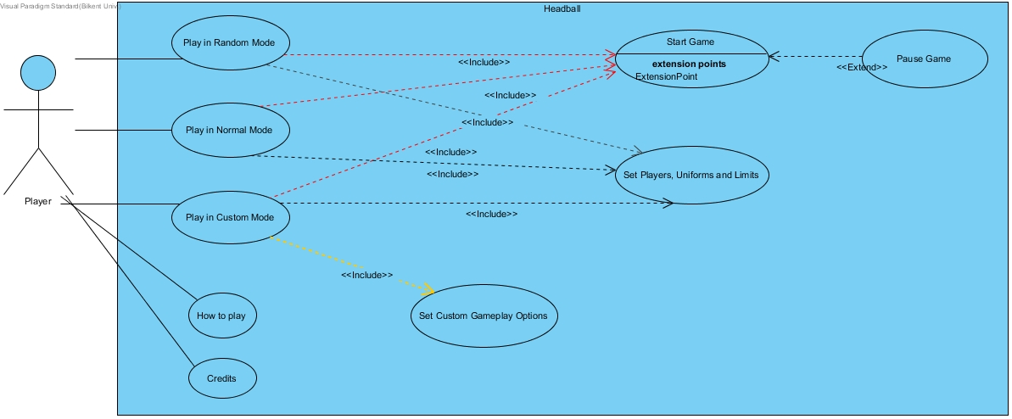

### 4.1.1 Play Game

The first Use Case Diagram demonstrates the gameplay:

Use Case #1

**1. Name:** Play in Random Mode or Play in Normal Mode. (Processes are the same for both.)

**2. Participating Actor:** Players

**3. Entry Conditions:**

* System is already opened and players are on the ‘Main menu’.
* One of players clicks on the “Play in Random Mode” or “Play in Normal Mode” button.

**4. Exit Condition:**

* Both of players set their ‘Handballer’ appearances, and
* Both of players set their uniforms and colors of skin, and
* Score and time limit is set, and
* One of players clicks on the “Start Game” button.

**5. Flow of events:**

1. System is opened.
2. ‘Main menu’ appears.
3. One of player clicks on the “Play in Random Mode” or “Play in Normal Mode” button.
4. ‘Normal Mode Game settings’ page or ‘Random Mode Game settings’ page is loaded.
5. Both of players set their ‘Handballer’ appearances.
6. Both of players set their uniforms and colors of skin.
7. Players set score and time limit.
8. One of players clicks on the “Start Game” button.

Use Case #2

**1. Name:** Play in Custom Mode

**2. Participating Actor:** Players

**3. Entry Conditions:**

* System is already opened and players are on the ‘Main menu’.
* One of players clicks on the “Play in Custom Mode” button.

**4. Exit Condition:**

* Both of players set their ‘Handballer’ appearances, and
* Both of players set their uniforms and colors of skin, and
* Score and time limit is set, and
* Type of ball is set, and
* Size of goals is set, and
* Background while playing is set.
* One of players clicks on the “Start Game” button.

**5. Flow of events:**

1. System is opened.
2. ‘Main menu’ appears.
3. One of player clicks on the “Play in Custom Mode” button.
4. ‘Custom Mode Game settings’ page is loaded.
5. Both of players set their ‘Handballer’ appearances.
6. Both of players set their uniforms and colors of skin.
7. Players set score and time limit.
8. Players set ‘type of ball’, ‘size of goals’ and ‘background’.
9. One of players clicks on the “Start Game” button.

Use Case #3

**1. Name:**  Start Game

**2. Participating Actor:** Players

**3. Entry Conditions:**

* Players have already chosen mode of the game and complete the settings.
* One of players clicks on the “Start Game” button.

**4. Exit Condition:**

* Time limit or score limit has expired.
* Players exit the game or go back to ‘main menu’ via ‘pause menu’.

**5. Flow of events:**

1. One of players clicks on the “Start Game” button.
2. System constructs the game.
3. Background, ‘handballers’ and goals are loaded.
4. Game starts with a whistle.
5. Players aim to score by jumping and hitting ball with keyboard keys.

Time limit or score limit has expired and system goes back to ‘main menu’ or players leaves from the game via ‘pause menu’.

Use Case #4

**1. Name:** Pause Game

**2. Participating Actor:** Players

**3. Entry Conditions:**

* Both of players are already in the game and playing.
* One of players presses the pause button (Esc key).

**4. Exit Condition:**

* One of players presses the Esc key again, or
* One of players clicks on the ”Resume” button on the ‘pause menu’, or
* One of players click on the ”Restart” button on the ‘pause menu’, or
* One of players clicks on the ”Main menu” button on the ‘pause menu’, or
* One of players clicks on the ”Exit” button on the ‘pause menu’, or

**5. Flow of events:**

1. Players are already playing the game.
2. One of players presses the Esc key during the game.
3. Game is paused.
4. ‘Pause menu’ appears on the screen and background becomes dull.
5. One of players clicks on one of buttons on the ‘pause menu’ and they leave from ‘pause menu’.
   1. Player resumes game by pressing Esc key or clicking on the “Resume” button,
   2. Player resets score and time, and initializes the game by clicking on the “Reset” button.
   3. Player goes back to ‘Main Menu’ by clicking on the “Main menu” button.
   4. Players get out the game by clicking on the “Exit” button.

### 4.1.2 Non-Gameplay Interactions

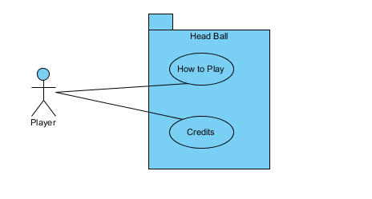

Use Case #1:

**Use Case Name:** How to Play

**Participating Actor:** Player

**Stakeholders and Interests:**

* Player does not know how to play or wants to get some information about game.
* Game displays key bindings, game mechanics and power ups information to player

**Pre-Condition:**

* Player clicks “How to Play” in main menu.

**Post-Condition:** None

**Entry Condition:**

* Player clicks “How to Play” in main menu.

**Exit Condition:**

* Player clicks “Back to Main Menu” button.

**Main Flow of Events:**

1. Player clicks “How to Play” button from the main menu.
2. After the player gets the information, s/he clicks “Back to Main Menu” button to return to main menu.

Use Case #2:

**Use Case Name:** Credits

**Participating Actor:** Player

**Stakeholders and Interests:**

* Player wants to see who made the game.
* A new window displays the names of those who worked on the game.

**Pre-Condition:**

* Player clicks “Credits” in main menu.

**Post-Condition:** None

**Entry Condition:**

* Player clicks “Credits” in main menu.

**Exit Condition:**

* Player clicks “Back to Main Menu” button.

**Main Flow of Events:**

1. Player clicks “Credits” button from the main menu.
2. After the player gets the information, s/he clicks “Back to Main Menu” button to return to main menu.

## 4.2 Activity Diagram

Here is the Activity Diagram of Headball:

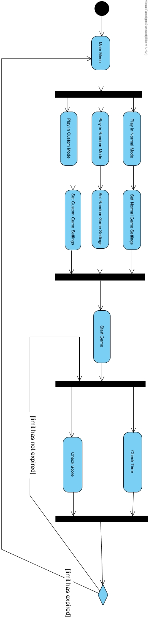

## 4.3 Class Diagram

Here is the Class Diagram of Headball:

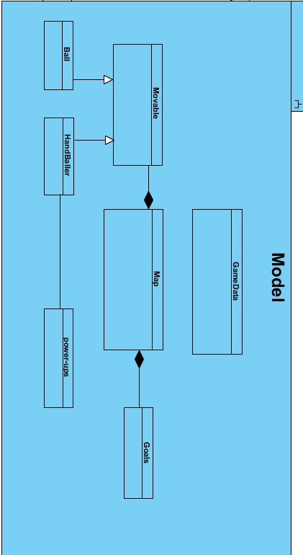

## **4.4 Sequence Diagrams**

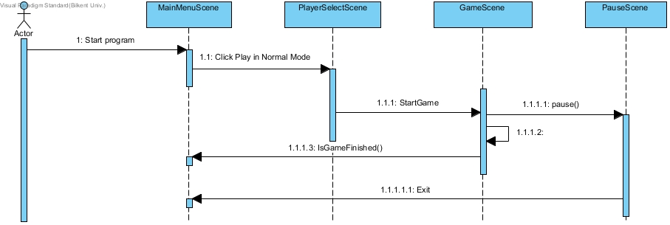Here are our sequence diagrams

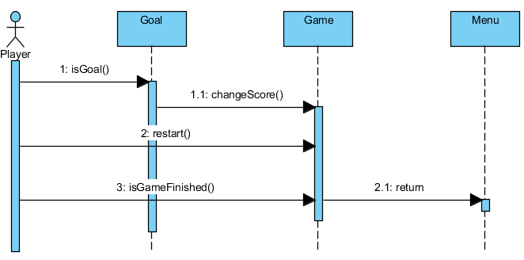

## 

## **4.5 State Diagram**

Here is our state diagram.

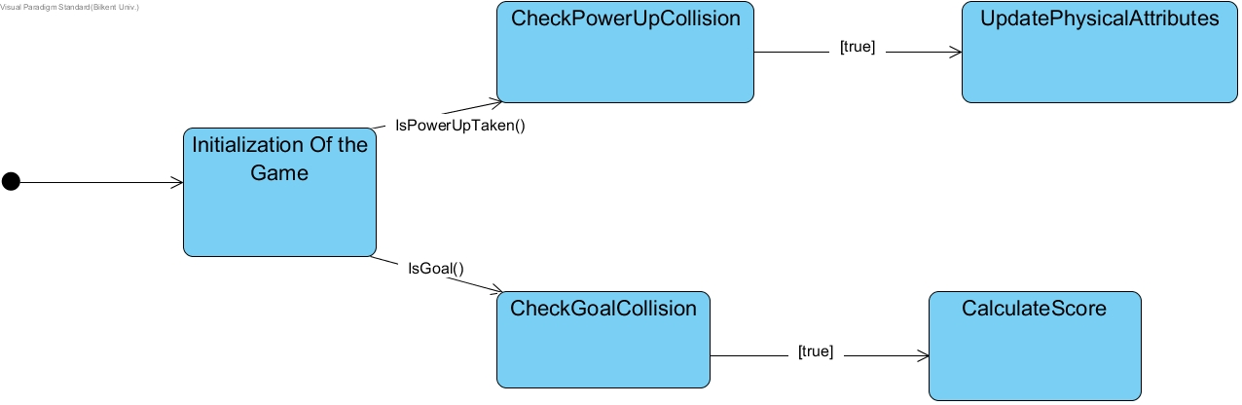

## **4.6 Mock-Ups**

### 4.6.1 Main Menu:



Main menu consists of five buttons:

* **Play**: Opens the player select menu.
* **Settings**: User can change sound settings from this menu.
* **Credits**: Shows the names of the people who worked on the game.
* **How to Play**: Shows key bindings.
* **Exit**: Exits the game.

### 4.6.2 Player Select Menu:

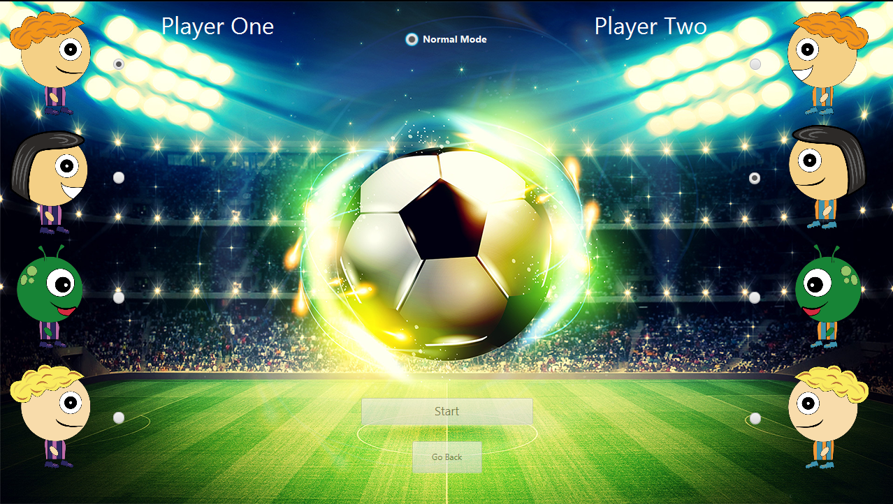

Player select menu consists of two buttons and three radio buttons group.

* **Player One Select:** First user can select his character from these 4 different avatars. Default is the first avatar. This player’s goal will be on the left side.
* **Player Two Select:** Second user can select his character from these 4 different avatars. Default is the second avatar. This player’s goal will be on the right side.
* **Game Mode Select:** Players can select different game modes from here. Default is “Normal”. Note: current implementation of the game only supports “Normal Mode”.
* **Start:** Starts the game with the selected avatars and mode.
* **Go Back:** Returns to the previous menu (main menu).

### 4.6.3 Settings Menu:



Settings menu consist of one checkbox and one button:

* **Sound:** User can turn on/off the sound of the game. On by default.
* **Go Back:** Returns to the previous menu (main menu).

### 4.6.4 Credits Menu:

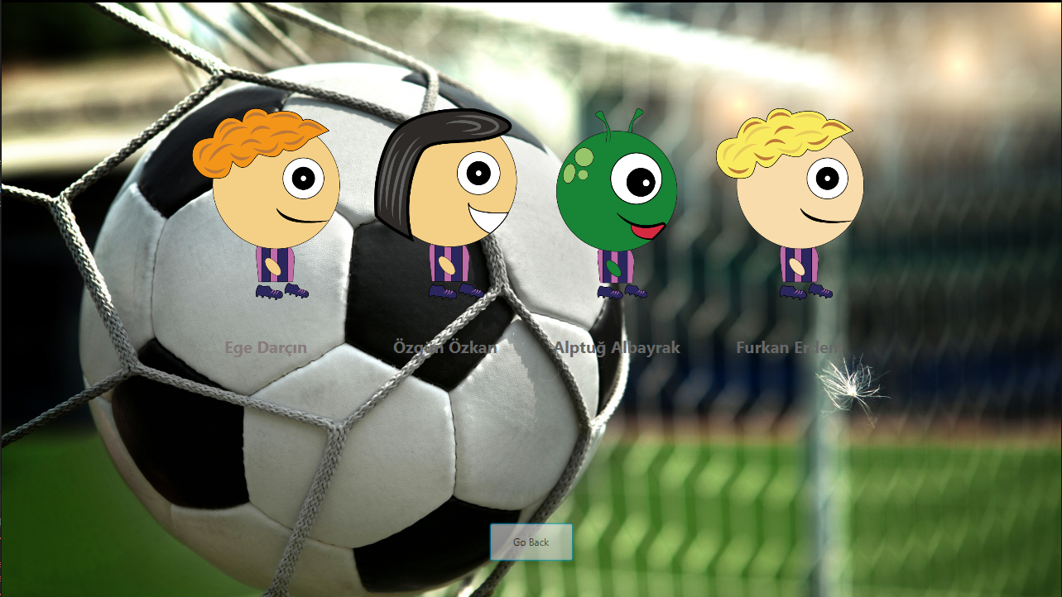

Credits menu consist of group member names and a “Go Back” button to return to the previous menu.

### 4.6.5 How to Play Menu:

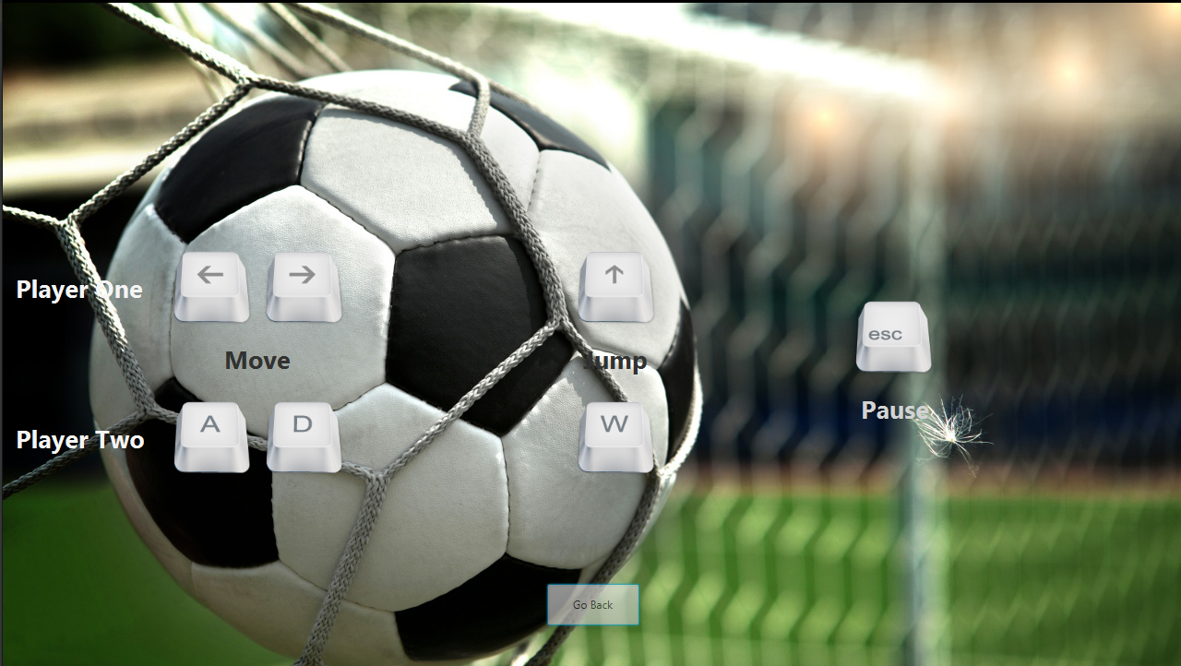

How to play menu consist of key bindings of the game and a “Go Back” button to return to the previous menu.

### 4.6.6 In Game Screen:

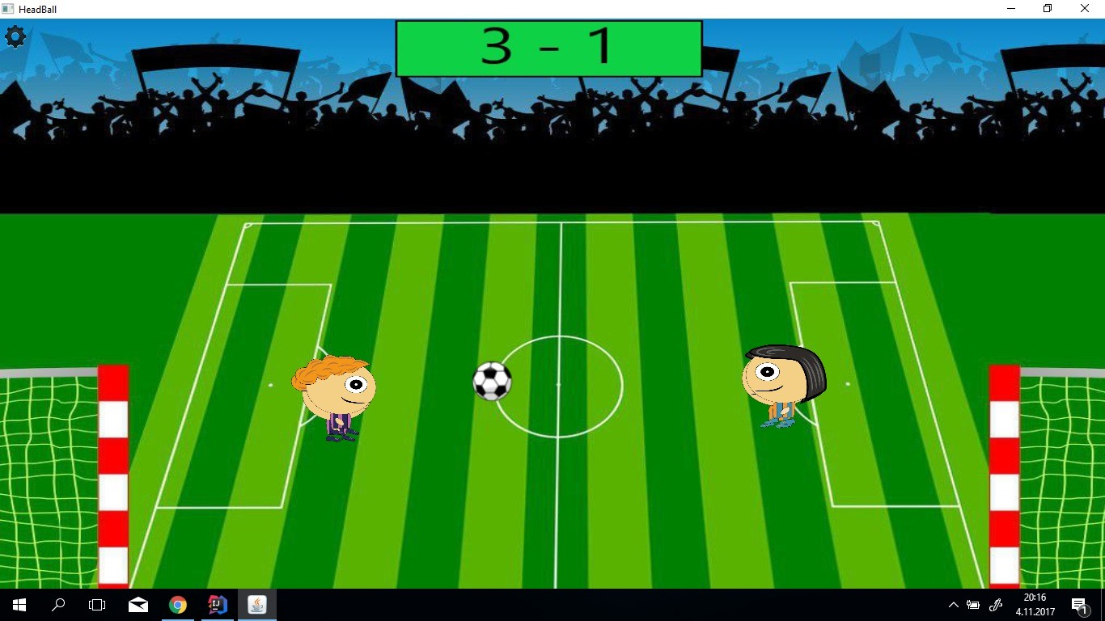

In the game, players will use their headballers to score goals. With arrow keys and w,a and d, players command their headballers to score goals.

To the moment, no powerups are implemented and frame paint rate issue is at hand, but they are soon to be implemented/fixed.

If players press escape or click the icon on the top left of the screen, options menu will pop up and bring out the pause menu.